ADVANCED PROGRAMMING

C-CS219

***Spring 2025***

***Astronomy chatbot***

Team Members

|  |  |
| --- | --- |
| Student Name | Student ID |
| Maroska Osama | 23-101209 |
| Dania Hassan | 23-101147 |
| Jana Abdelmoniem | 23-101148 |
| Mohamed Mostafa | 24-101222 |

Table of contents

1. Abstract
2. Introduction
3. Motivation
4. System design

* System modules and functions
* Hierarchy chart

1. Description
2. Team’s workload distribution
3. User manual
4. Testing and validation
5. Challenges and conclusion

References

The abstract:

In a universe full of mysteries, what if you could explore the wonders of space through a friendly, intelligent guide? This project introduces an interactive astronomy chatbot developed in Scala, designed to simulate conversation, deliver space-related facts, and assess user knowledge through quizzes—all while showcasing the power of functional programming. Leveraging pattern matching, immutable data structures, and pure functions, the chatbot provides a seamless educational experience. Whether you're curious about black holes or eager to test your knowledge of the solar system, this chatbot blends learning with conversation, bringing the cosmos a little closer—one message at a time.

The introduction:

What if learning about the universe felt more like chatting with a friend than reading a textbook? That’s exactly what we set out to build with our **Astronomy Chatbot**—a conversational assistant powered by Scala and functional programming principles. Designed for both **terminal** and **GUI using python**, the chatbot delivers an engaging, interactive experience that makes space science accessible and enjoyable.

Our chatbot doesn’t just respond to commands—it **holds friendly conversations**, shares **random and fascinating astronomy facts**, and offers two styles of quizzes: a **traditional knowledge-based quiz** to test what you know, and a **personality-style quiz** that analyzes your answers to give you a space-themed result (e.g., “Which celestial object are you?”).

From black holes to supernovas, the chatbot makes exploring the cosmos feel less like a lecture and more like a journey—whether you're curious, competitive, or just killing time under the stars.

What made us choose the astronomy chatbot?

🌠 **A love for the stars**: Space is vast, beautiful, and mysterious. We wanted to share that excitement with others in a way that’s easy to access and enjoy.

🧠 **Combining education with interaction**: We aimed to create more than a bot that answers questions. We envisioned a learning companion that talks, quizzes, and responds like a curious friend.

💬 **Making conversations meaningful**: Most chatbots feel robotic. Ours is different—it tells random fun facts, answers intelligently, and keeps users engaged with a natural tone.

🧪 **Showcasing Scala’s potential**: We wanted to prove that Scala, often seen as complex, can power friendly and functional applications using features like pattern matching, immutable structures, and pure functions.

🌐 **Reaching users everywhere**: With both terminal and web versions, we ensured our chatbot is flexible and accessible no matter how users choose to interact.

the hierarchy chart:

The functions used in our program:

1. **Main.main** - Program entry point that initializes all components and launches the chatbot.
2. **mainLoop** - Primary execution loop for processing user input and displaying responses.
3. **initializeDataSource** - Sets up astronomy data sources and creates sample data if needed.
4. **createSampleDataFile** - Creates a basic astronomy data file when none exists.
5. **promptUserName** - Requests and captures the user's name for personalized interactions.
6. **displayWelcomeBanner** - Shows ASCII art and welcome message at startup.
7. **QuizManager.apply** - Factory method that creates a new QuizManagerImpl instance.
8. **QuizManagerImpl.handleMessage** - Processes user input during quiz mode.
9. **QuizManagerImpl.isQuizActive** - Checks if a quiz is currently running.
10. **QuizManagerImpl.resetQuizState** - Resets the quiz state after completion.
11. **InputParser.parseInput** - Converts user text into structured commands.
12. **ResponseGenerator.respond** - Main response generation function based on commands.
13. **ResponseGenerator.getSolarSystemFact** - Gets random solar system facts.
14. **ResponseGenerator.getPlanets** - Returns list of planets in the solar system.
15. **ResponseGenerator.getFacts** - Retrieves facts about a specific astronomy topic.
16. **ResponseGenerator.formatPlanetResponse** - Creates formatted planet information.
17. **ResponseGenerator.formatCategoryResponse** - Formats responses about astronomy categories.
18. **ResponseGenerator.getRandomUnknownResponse** - Generates responses for unrecognized inputs.
19. **ResponseGenerator.getRandomGreeting** - Provides random greeting messages.
20. **ResponseGenerator.getHelpMessage** - Returns help text showing available commands.
21. **ResponseGenerator.greetUser** - Creates personalized user greeting.
22. **ResponseGenerator.formatQuizResponse** - Formats quiz output with colors/styling.
23. **ResponseGenerator.compareBetween** - Compares two astronomical objects.
24. **ResponseGenerator.compareProperties** - Helper method for comparing object properties.
25. **ResponseGenerator.generateUniqueFeatures** - Identifies unique features between objects.
26. **ResponseGenerator.formatComparisonResponse** - Formats object comparison output.
27. **ResponseGenerator.UnexpectedInput** - Handles special case inputs with appropriate responses.
28. **ResponseGenerator.compareBasicInfo** - Compares basic information between objects.
29. **ResponseGenerator.comparePhysicalCharacteristics** - Compares physical traits between objects.
30. **ResponseGenerator.compareEnvironment** - Compares environmental conditions between objects.
31. **ResponseGenerator.compareOrbitalCharacteristics** - Compares orbital properties between objects.
32. **AnalyticsImpl.logInteraction** - Records user command patterns.
33. **AnalyticsImpl.getTotalInteractions** - Returns total number of user interactions.
34. **AnalyticsImpl.getMostFrequentCommand** - Identifies most commonly used command.
35. **AnalyticsImpl.getCommandStatistics** - Returns statistics on all command usage.
36. **DataLoader.loadAstronomyData** - Loads astronomy data from JSON files.

The description of our code contains the explanation:

| **Function Name / Value** | **Purpose** | **Detailed Explanation for object constants** |
| --- | --- | --- |
| CMD_* constants | Store predefined command identifiers | Used to standardize chatbot commands like HELP, START_QUIZ, etc., so different modules can reference them consistently. |
| helpWords, listWords, etc. | Word lists for intent matching | These are lists of synonyms and trigger phrases used by the chatbot to detect what the user is trying to say (e.g., asking for help or requesting a list of planets). |
| planets and categories | Domain-specific keywords | These are lists of actual celestial body names and categories that the chatbot recognizes and understands. |
| Function Name / Value | Purpose | Detailed Explanation for object colors |
| Reset, Red, Green, etc. | ANSI escape codes for terminal text formatting | Used to print colored or styled text in the terminal, useful for emphasizing errors or important messages (e.g., red for warnings). |

| **Function Name / Value** | **Purpose** | **Detailed Explanation for object config** |
| --- | --- | --- |
| load: Config | Load configuration object | Currently returns a default instance of Config. Placeholder for future enhancements like loading settings from a file. |

| **Function Name / value** | **Purpose** | **Detailed Explanation for object data loader** |
| --- | --- | --- |
| loadAstronomyData(filename) | Load JSON astronomy data from a file | Parses a JSON file containing an array of celestial objects. It manually splits and converts each object string into a Map[String, String], indexed by lowercase object names. |
| splitObjects(str) | Helper to split raw JSON array into objects | Iterates through characters while tracking braces and quotes to accurately extract JSON object strings. |
| parseObject(objectStr) | Convert a JSON object string to key-value map | Parses individual object strings into a Map, cleaning quotes and commas. |
| splitKeyValuePairs(str) | Break a JSON object into key-value strings | Tracks brackets and quotes to safely split on commas that separate fields. |
| loadSpaceObjectsData(filename) | Load CSV-based space object data | Parses a CSV file into a map from object names to field maps. It handles quoted commas and malformed lines. |
| mergeData(jsonData, csvData) | Combine JSON and CSV data | Merges the two sources. If an object is in both, the CSV fields override the JSON ones. |
| astronomyData (lazy val) | Lazy-loaded merged astronomy dataset | Combines parsed JSON and CSV files using mergeData. |
| spaceObjectsData (lazy val) | Lazy-loaded space object dataset from CSV | Loads CSV file only once on demand. |

| **Function Name** | **Purpose** | **Detailed Explanation for object InputParser** |
| --- | --- | --- |
| parseInput(input, isQuizActive) | Main input dispatcher | Normalizes input and routes to quiz mode or regular mode. Translates input into an internal command string like startquiz or compare_earth_mars. |
| containsAny(words, targetList) | Check if input contains any keyword | Returns true if at least one word in words matches an item in targetList. |
| matchesGreetings(words) | Detect greeting input | Uses containsAny to match against greeting keywords. |
| matchesHelp(words) | Detect help-related input | Identifies if user is asking for help or instructions. |
| matchesListPlanets(words) | Detect requests to list planets | Matches combinations of list words and "planets". |
| matchesRandomFact(words) | Detect random fact request | Flexible matching for various ways of asking for a fact. |
| matchesQuiz(words) | Detect quiz intent | Matches quiz-related words like "test", "challenge". |
| matchesCompare(input) | Detect comparison input | Checks whether comparison-related terms exist in the input string. |
| matchesCategory(words) | Detect category listing intent | Matches input against known astronomy categories. |
| matchesPlanet(words) | Detect planet-specific input | Looks for any known planet name in the words. |
| extractCompareTopics(input) | Extracts two objects to compare | Replaces all comparison-related keywords with delimiters and extracts two non-empty topics. |
| extractTopic(input) | Cleans user queries to extract topic | Removes prefixes ("tell me about...") and filler words to isolate a clean topic keyword. |
| parseQuizMode(words, input) | Command parsing during quiz mode | Recognizes commands like "exit quiz", "skip", or considers anything else as an answer. |
| parseRegularMode(words, input) | Command parsing during regular mode | Detects commands like HELP, LIST_PLANETS, or extracts a topic, falling back to CMD_UNKNOWN if no clear intent is found. |

| **Function/Method** | **Purpose** | **Detailed Explanation for quizmanagerimpl** |
| --- | --- | --- |
| resetQuizState() | Resets the state of the quiz. | This method resets the quizState to None, effectively ending the current quiz session and clearing any saved progress or results. |
| isQuizActive() | Checks if a quiz is currently active. | This method returns a boolean value indicating whether the quizState is Some (indicating an active quiz session) or None (indicating no active quiz). |
| selectQuizQuestions(topic: String) | Selects quiz questions based on the given topic. | Based on the input topic, this method returns a list of Question objects. It supports two topics: "traditional" (astronomy-related questions) and "personal" (questions based on user preferences or general knowledge). If an invalid topic is given, it returns a "Topic not found" question. |
| normalizeNumber(input: String) | Normalizes numeric inputs to remove unwanted characters. | This method removes non-numeric characters (such as letters and symbols) and standardizes the input to a clean number format (e.g., stripping commas, trimming whitespace). It is used for comparing numeric answers in the quiz. |
| compareNumbers(answer: String, correct: String, tolerance: Double = 0.1) | Compares the user's numeric answer to the correct answer with a tolerance. | This method normalizes the user's answer and the correct answer, then compares them numerically. The comparison allows for a small tolerance (default is 0.1), meaning the answer is considered correct if the difference between the two numbers is within this margin. |
| checkSynonyms(userAnswer: String, correctAnswer: String) | Checks if the user's answer contains any synonyms of the correct answer. | This method checks if the user's answer contains any word or synonym from a predefined list of synonyms stored in synonymMap. It returns true if a synonym match is found for both the user’s and correct answer, making the comparison more flexible and forgiving of different terms for the same object. |
| isNumericAnswer(answer: String) | Determines if the provided answer is numeric. | This method checks whether the provided answer contains any digits, returning true if it's a numeric answer (including decimal numbers) and false otherwise. |
| presentQuestion(questions: List[Question], index: Int) | Presents a question at the specified index. | This method retrieves the question at the given index from a list of Question objects. If the index is within the bounds of the list, it returns the question with its options; otherwise, it notifies that no more questions are available. |
| processTopicSelection(message: String) | Processes the user’s topic selection for starting a quiz. | This method takes the user's message as input and checks for valid quiz type selections (e.g., "traditional" or "personal"). It updates the quizState accordingly and returns the first question for the selected topic. If an invalid option is selected, it requests the user to choose a valid quiz type. |
| levenshteinDistance(s1: String, s2: String) | Calculates the Levenshtein distance between two strings. | This method computes the number of single-character edits (insertions, deletions, substitutions) required to change one string into another. It is used for fuzzy matching when comparing the user’s input to valid options, allowing for minor spelling errors. |
| findClosestMatch(input: String, options: List[String]) | Finds the closest matching option from a list based on Levenshtein distance. | This method takes the user's input and attempts to find the closest match in a list of options by calculating the Levenshtein distance between the input and each option. It returns the closest match if the distance is within a tolerance (distance of 2 or less). |
| validateQuizAnswer(answer: String, options: List[String]) | Validates the user’s answer against a list of options. | This method checks if the user's answer matches one of the valid options (case insensitive). It also checks if the answer is a close match using fuzzy matching (Levenshtein distance). The answer is considered valid if it matches or closely resembles one of the provided options. |
| handleQuizAnswer(answer: String) | Handles and processes the user’s answer to the current quiz question. | This method checks the validity of the user’s answer. If the answer is valid, it checks if the answer is correct (for both traditional and personal quizzes). The method updates the quiz state (quizState) and progress, providing feedback (correct/incorrect) and advancing to the next question or completing the quiz. |

| **Name** | **Type** | **Detailed Explanation for QuizManagerImpl** |
| --- | --- | --- |
| quizState | Option[QuizState] | This mutable variable holds the user's ongoing quiz session as an Option. When defined (Some), it contains:– selected topic– question list– current index– correct answer count– question results (user answers + correctness). |
| QuizState | case class | Includes:– topic: String: the quiz topic (e.g., "traditional")– questions: List[Question]: the selected quiz questions– currentIndex: Int: which question the user is currently on– correctCount: Int: how many answers were correct– results: List[(String, Boolean)]: each user answer and whether it was correct |
| Question | case class | Fields:– text: String: the question itself– options: List[String]: possible answers– correctAnswer: String: the correct option– explanation: Option[String]: optional explanation shown after the user answers. |
| synonymMap | Map[String, Set[String]] | A mapping from keywords (e.g., "mars") to sets of valid alternatives (e.g., {"the red planet", "planet mars", "mars"}). Used to validate free-form answers by comparing inputs against all synonyms. |
| traditionalQuestions | List[Question] | Predefined multiple-choice questions focused on scientific topics like planets, distances, and physical properties. Each entry is a Question object with options and explanations. |
| personalQuestions | List[Question] | A more relaxed question set with personal or imaginative themes (e.g., favorite planet, living on Mars). Designed to be fun or reflective rather than scientifically strict. |

| **Function / Part** | **Purpose** | **Description for QuizManager** |
| --- | --- | --- |
| updateQuizResults | Updates cumulative quiz results for a topic | Takes the previous quiz results, the topic, and new answers. It updates the score and question count if the topic exists or adds a new topic entry. |
| generateQuizSummary | Generates a summary of the most recent quiz attempt | Returns a formatted string summarizing correct answers, total questions, percentage score, and question review—adapted based on the topic type. |
| endQuiz | Ends the current quiz session | Finalizes the quiz, clears the quizState, and returns a summary if answers were given, or a message if the quiz was not attempted. |
| getQuizSummary | Shows cumulative quiz performance | Aggregates and displays total scores and accuracy percentages per quiz topic from all past attempts. |
| handleMessage | Main message handler for quiz interactions | Determines context (awaiting topic/answer) and dispatches user input to the right function. Also handles commands like "start quiz", "help", etc. |
| QuizManager | Factory method for creating QuizManagerImpl objects | Allows instantiating the QuizManagerImpl with encapsulated state and logic. |
| Function / Part | Purpose | Description for QuizManager |
| updateQuizResults | Update the results of a completed quiz | Updates the stored QuizResults for a given topic by adding the new correct and total answers; if the topic is new, it appends a new entry. |
| generateQuizSummary | Generate a detailed summary of a completed quiz | Builds a quiz summary string with score and per-question feedback, adjusting formatting for "traditional" and "personal" quiz types. |
| endQuiz | End the current quiz session | Ends the quiz, generates a summary if answers exist, clears quiz state, and returns an appropriate message. |
| getQuizSummary | Retrieve a summary of all quiz history | Returns a formatted history of all completed quiz results stored in quizResults. |
| handleMessage | Main dispatcher for handling user input in quiz mode | Routes the user message based on current quiz state and input content, supporting quiz start, answers, summaries, help, etc. |
| QuizManager.apply | Factory method to create a quiz manager instance | Instantiates a new QuizManagerImpl object. |

| **Function/Part** | **Purpose** | **Detailed Explanation** |
| --- | --- | --- |
| comparePhysicalCharacteristics | Compare physical features of two astronomical objects. | Takes two Map[String, String] objects (e.g., for planets). Uses safe lookups with .get(...) to extract "diameter", "mass", and "surface_composition". Builds comparison strings for each attribute. If data exists, returns a formatted string with the comparisons; otherwise returns None. |
| compareEnvironment | Compare environmental conditions of two objects. | Extracts "temperature", "atmosphere", and "moons" fields using .get(...). Constructs human-readable comparison lines (e.g., atmosphere type or moon count). Returns None if no comparable data is found. Otherwise returns a multi-line string. |
| compareOrbitalCharacteristics | Compare orbital data like distance from Sun and rotation period. | Safely extracts "distance_from_sun", "orbital_period", and "rotation_period" from each object. Builds formatted comparison strings. Skips fields that are missing in either object. Returns a combined string or None if nothing to compare. |
| UnexpectedInput | Respond to non-command inputs like jokes, emotional queries, or greetings. | Cleans the input (trims, lowercases), matches it against a list of predefined responses (e.g., “I love you”, “tell me a joke”), and returns a witty or relevant message. If the input isn’t recognized, it calls getRandomUnknownResponse() to generate a fallback reply. |
| respond | Main chatbot routing function. | Receives a command, data, logger, and quiz manager. Handles various commands: unknown_* → UnexpectedInput, help → help message, listplanets/listcategory_* → lists from dataset, randomfact → random fact, askabout_* → specific data lookup, compare_*_* → invokes comparison functions, greetings → greeting response. Central command dispatch logic. |
| getDataForObject | Retrieve detailed data for a specific object. | Calls getDataForCategory with appropriate category and object key. Retrieves specific data stored in the astronomical_objects object (like "mass", "diameter", etc.). |
| getDataForCategory | Retrieve all data for a specific category (e.g., planets, stars). | Searches the dataset for a specific category like planets, stars, and returns the list of objects (e.g., names). For each object in the category, retrieves detailed information for use by other functions. |
| getRandomFact | Retrieve a random fact about astronomical objects. | Selects a random object from a predefined list (e.g., planets, stars) and calls a function like getDataForObject to gather a fact about it. Can include physical characteristics or environmental data. |
| getRandomUnknownResponse | Return a random default response for unrecognized input. | Randomly selects a message from a predefined list to respond when input does not match known commands or queries. |
| listPlanets | List all planets in the dataset. | Extracts the names of all planets from the astronomical_objects dataset and formats them into a readable list. |
| listCategoryPlanets | List all objects in the planets category. | Uses the getDataForCategory function to list all objects in the planets category. |
| listCategoryStars | List all objects in the stars category. | Uses getDataForCategory to retrieve and list all objects from the stars category. |
| getQuizQuestions | Fetch a list of quiz questions from a dataset. | Retrieves a collection of questions and their answers for quiz generation. |
| getScore | Calculate the score of a user's answers in a quiz. | Evaluates the user’s responses to quiz questions, compares them to correct answers, and calculates the score. |
| updateQuizData | Update quiz progress and data. | Updates quiz-related data in a user’s session, ensuring the correct progress is tracked for each question, answer, and score. |
| addResponseToHistory | Add a user response to the history log for analysis. | Appends each user's response to a history list for tracking. This helps evaluate interactions with the chatbot. |
| parseCommand | Parse the user input and recognize the command type. | Parses the raw input from the user and identifies the corresponding command type, such as questions about planets, stars, or comparison operations. |
| getHelpMessage | Provide help information for commands. | Returns a list of available commands along with brief descriptions of what each command does. |
| compareData | Compare data from two objects. | Uses the compare functions (comparePhysicalCharacteristics, compareEnvironment, compareOrbitalCharacteristics) to compare multiple characteristics of two given astronomical objects. |
| loadAstronomicalData | Load all astronomical data from a predefined dataset. | Loads the dataset containing information about astronomical objects, including planets, stars, and other relevant categories for the chatbot to use during its interactions. |
| checkCommandValidity | Check if a command is valid or known. | Verifies whether the user's command exists in the predefined list of available commands. If the command is not recognized, responds with an error message. |
| getDetailedObjectData | Retrieve detailed information for a specific object. | Based on a recognized object or category, this function gathers a range of detailed data (physical, environmental, orbital) to be used in chatbot responses. |
| setUpLogger | Set up a logging mechanism for the chatbot. | Configures logging tools to track chatbot interactions, errors, and responses, for debugging and analytics. |

The workload distribution:

| **Team Member** | **Tasks** |
| --- | --- |
| **Maroska Osama** | **Coding Tasks:** |
|  | - Implement functions for the astronomy chatbot (answer checking, quiz logic, core functions related to quiz processing) |
|  | - Handle error fixing and code optimization |
|  | - Implement synonym handling for quiz answers |
|  | - Address spelling mistakes and handle fuzzy matches in input parsing |
|  | - Implement and maintain the quiz state management |
|  | **Documentation & Explanation:** |
|  |  |
|  | - made the report |
|  | **Testing & Debugging:** |
|  | - Test the core quiz functionality, check for bugs and edge cases |
|  | **Collaboration:** |
|  | - Assist with integration tasks and provide input for improving input parsing and response handling |
| **Mohamed Mostafa** | **Web Server Development:** |
|  | - Set up and maintain the web server for the astronomy chatbot |
|  | - Integrate the backend chatbot with the frontend |
|  | **Backend Development:** |
|  | - Work on data flow and communication between the chatbot and the web server |
|  | **Testing & Deployment:** |
|  | - Conduct tests to ensure proper communication and functionality between the web server and the chatbot |
|  | - Assist with debugging and deployment  - helped in parser input and the main function |
| **Dania Hassan** | **Input Parsing:** |
|  | - Work on parsing user inputs and mapping responses |
|  | - Handle special cases for user input (e.g., greetings, unclear queries) |
|  | - Implemented validation functions for responses |
|  | **Testing & Debugging:** |
|  | - Test different types of inputs for handling edge cases |
|  | - Debug and optimize input parsing |
|  | **Collaboration:** |
|  | - Work closely with Maroska on testing quiz functionality and answer validation |
| **Jana Abdelmoniem** | **Presentation Development:** |
|  | - Create the PowerPoint presentation, including slides about the chatbot’s features, functions, and purpose |
|  | **Input Parsing Support:** |
|  | - Assist Dania in input parser development, particularly for greeting and user interaction functions |
|  | **Documentation:** |
|  | - Help with documenting the overall structure and major features of the project |
|  | **Collaboration:** |
|  | - Provide input on testing and the design of the user experience  Assist in troubleshooting and debugging issues related to user input and response handling |

The user manual:

There are many extra features the chatbot provides for the user that creates a better experience for user such as:

1. **Spelling & Synonym Support:**
   * The chatbot accepts spelling mistakes and synonyms to make interactions smoother.
   * Example: Typing "plannet" instead of "planet" is still accepted!

**Quiz History:**

* + Track your quiz results over time to see your improvement.
  + Example: "You scored 3 out of 5 in your last quiz. Try again?"

1. **Random Facts:**
   * Get interesting astronomy facts after each quiz.
   * Example: "Did you know? A day on Venus is longer than a year on Venus!"
2. **Color-Coding Questions:**
   * Correct answers turn green, incorrect answers turn red for instant feedback.
3. **Exit Quiz Anytime:**
   * Exit the quiz at any time and continue with the chatbot or close the server.
   * Example: "Exit quiz? Type 'continue' to resume or 'close' to stop."
4. **Webserver Integration:**

* The chatbot allows users to interact with it through a web interface, making it more accessible and visually appealing.
* Example: If a user types "Start Quiz," the backend communicates with the frontend and begins the quiz session seamlessly.

How to use our system?

1. **Launch the Chatbot**
   * Open the chatbot interface (through the web server or terminal).
   * The chatbot will greet you and prompt you to begin the interaction.
2. **Start a Conversation**
   * Type your first question or greeting (e.g., “Hello”, “Hi”, “What is astronomy?”).
   * The chatbot will respond with relevant information based on the greeting or query.
3. **Ask Astronomy-Related Questions**
   * You can ask questions about celestial bodies, space facts, astronomical events, and more.
   * Examples:
     + "What is a black hole?"
     + "Tell me about Mars."
     + "compare earth and vega”
4. **Take the Astronomy Quiz**
   * The chatbot will offer you the option to take a quiz about astronomy.
   * Answer the questions by typing your responses.
     + Correct answers are acknowledged with positive feedback and green colored.
     + Incorrect answers will prompt a brief explanation and red colored question.
5. **Enjoy Synonym and Spelling Correction**
   * The chatbot accepts common synonyms and spelling mistakes.
   * Example: If you type “planet” or “planit”, it will still recognize and respond appropriately.
6. **Use Special Commands**
   * **Exit Quiz:** You can exit the quiz at any time by typing “Exit” or “Quit”.
   * **Check Quiz History:** Type “Quiz History” to see a list of previously taken quizzes and your performance.
   * **Ask for Fun Facts:** Type “Tell me a fun fact” to get random astronomy-related facts.
7. **Customize the Experience**
   * **Personalized Questions:** Ask specific questions about your favorite planets, stars, or galaxies, and the chatbot will give tailored responses.
8. **Receive Feedback and Learn**
   * After each quiz, the chatbot will provide feedback on your performance.
   * Use this to learn and improve your knowledge of astronomy.
9. **Get Assistance**
   * If you encounter any issues, the chatbot will try to resolve them by offering suggestions or asking clarifying questions.
   * If you need a menu with the options just type help.
10. **End Session**
    * You can close the chatbot interface or exit the conversation at any time.
    * The chatbot will thank you for using the service and provide an option to continue or exit.

### Additional Features:

* **Random Facts:** Type “Tell me a random fact” for interesting space facts.
* **Color-Coded Feedback:** Questions will be color-coded based on your answer (green for correct, red for incorrect).
* **Web Server Control:** You can close or keep the web server running while interacting with the chatbot

Testing and validation:

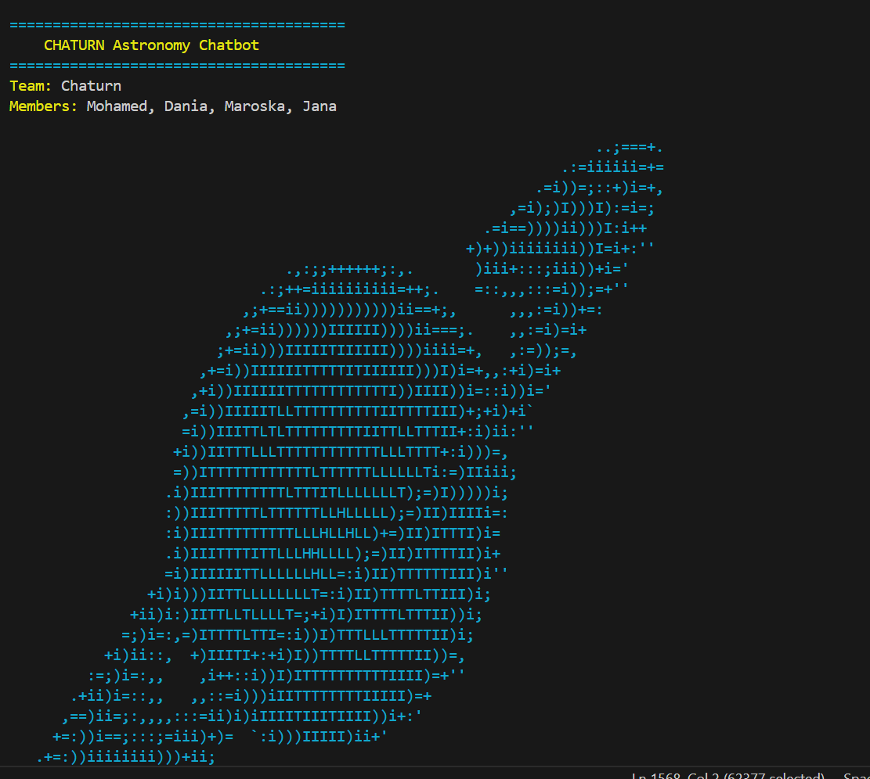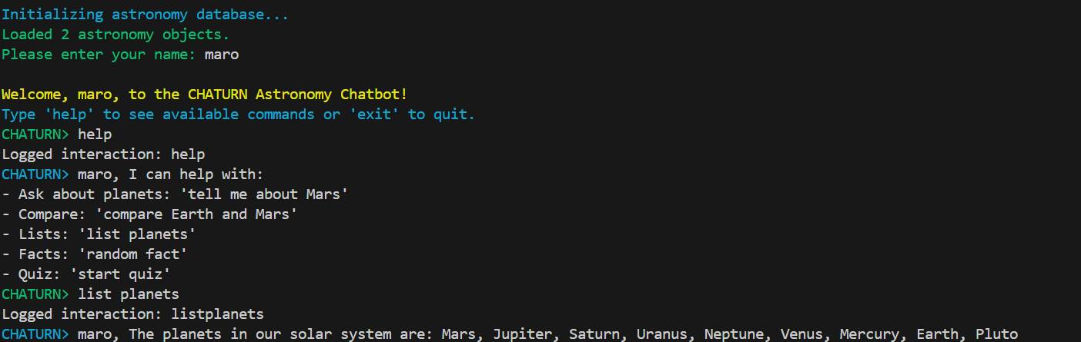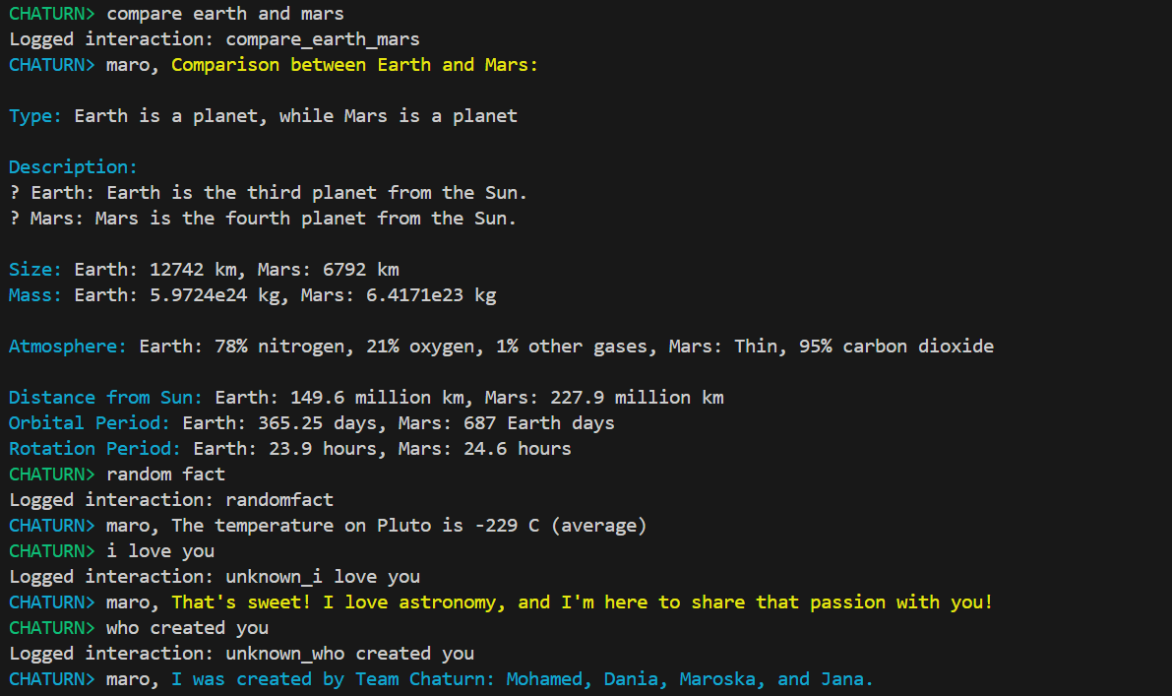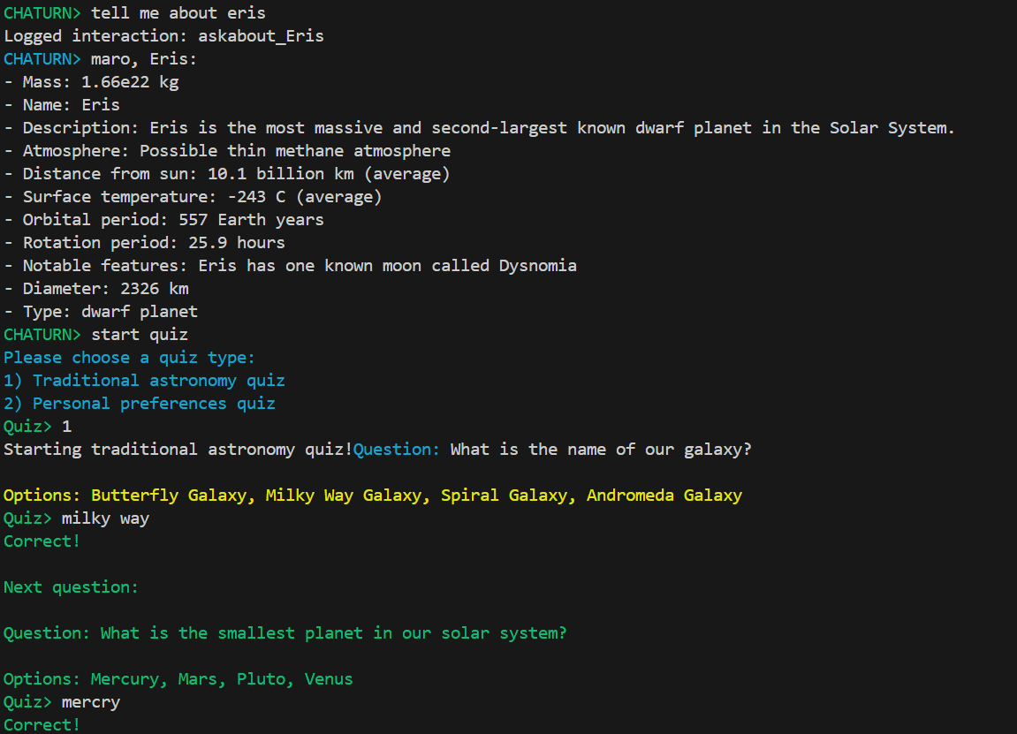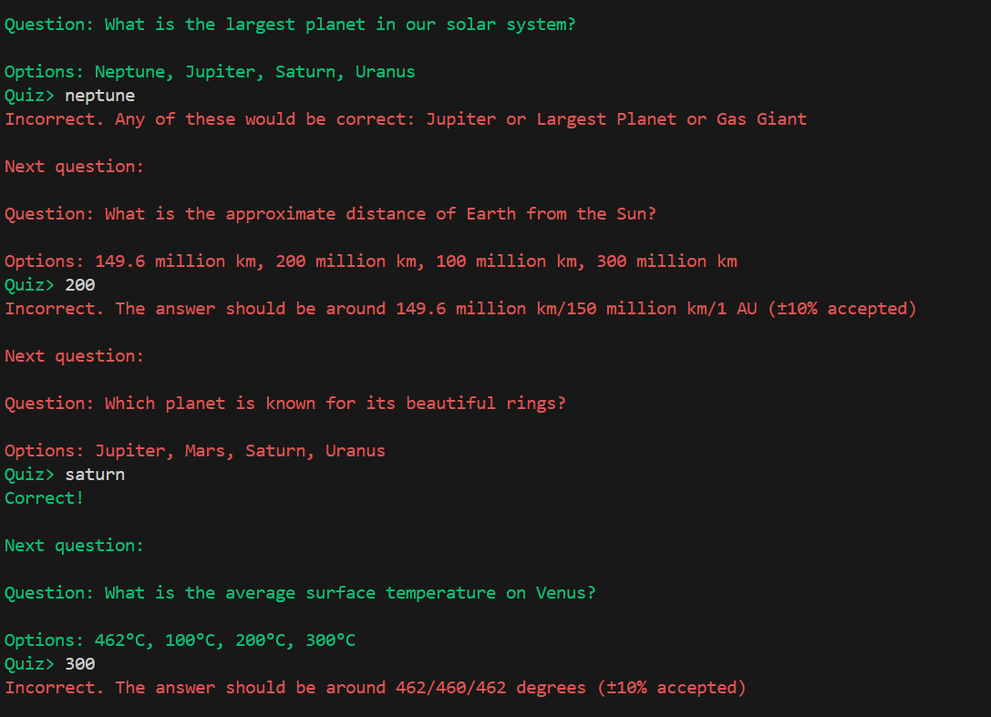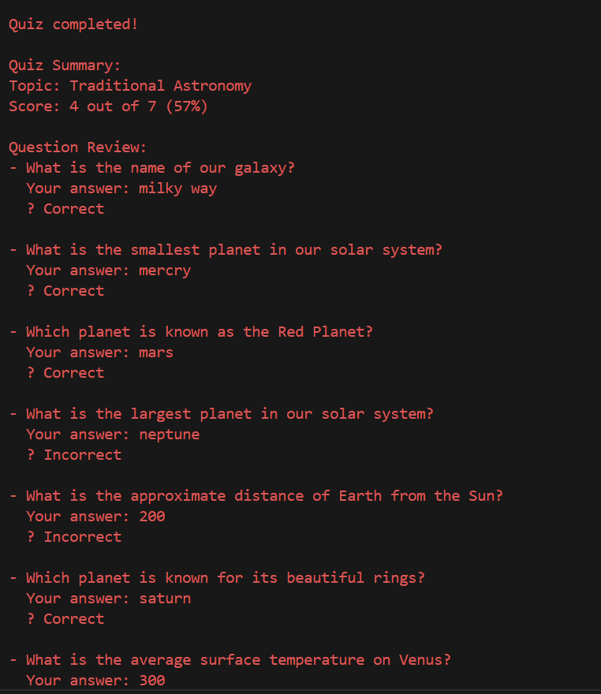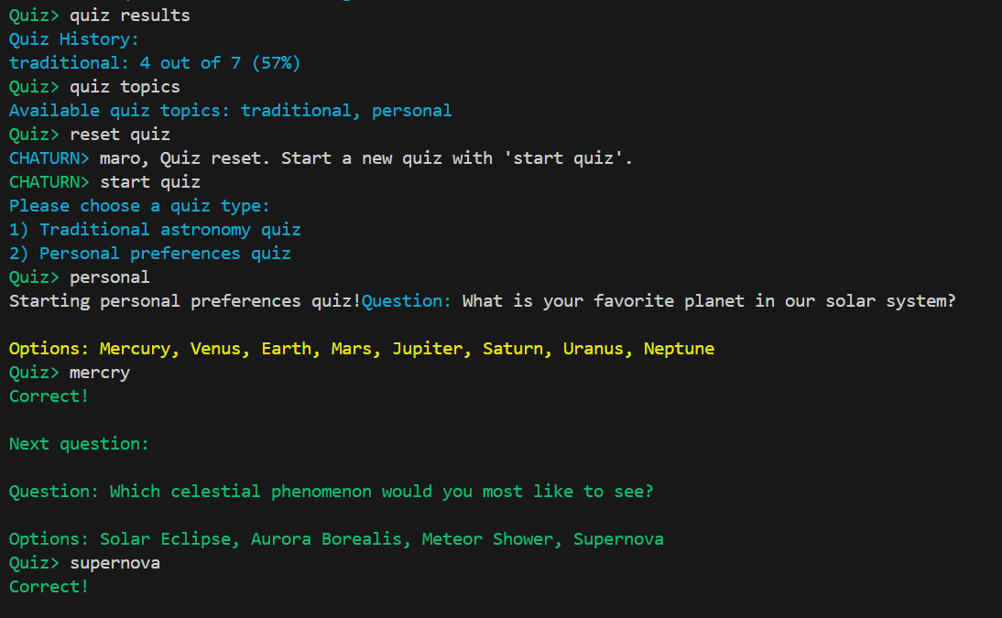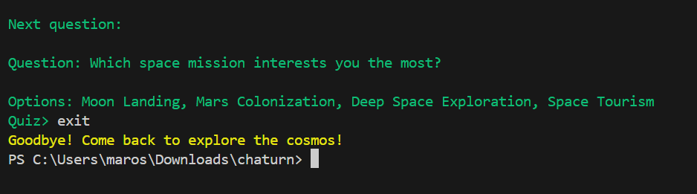

The conclusion and challenges:

**Complex Input Parsing**: Handling misspellings, synonyms, and ambiguous inputs.

**Synonym and Spelling Correction**: Ensuring variations in wording were processed correctly.

**Quiz Logic and State Management**: Implementing interactive quiz functionality and tracking progress.

**Web Server Integration**: Synchronizing backend and frontend for smooth communication.

**Error Handling**: Preventing unexpected errors and managing edge cases.

**Testing and Debugging**: Identifying and resolving bugs in the system.

The overall astronomy chatbot project delivers an engaging and user-friendly platform for learning about space. With features like quiz functionality, synonym and spelling handling, and color-coded feedback, it creates an interactive and personalized experience. Additional functions, such as random facts and quiz history, enhance user engagement. Overall, the chatbot is a valuable educational tool, offering both flexibility and insight, making space exploration accessible and enjoyable for everyone.